Harmonic Motion
Lab #1 Redo
Matthew Dietrich-Blocker
T.A.: Brandon Seilhan

STATEMENT OF OBJECTIVE

The objective of this lab was to study simple harmonic (SHM) motion using pendulums and springs, and to become familiar with the oscilloscope.

THEORY

When an object is moving in a periodical motion it is said to be in harmonic motion. The most fundamental type of this motion is known as SHM. This simple type of motion is common in physics, from mechanics to electromagnetism.

When a spring is stretched or compressed from its natural length and released it will exhibit SHM. When compressed the spring will have the potential energy to expand. Once released it expands and at the point of maximum expansion, it will have potential energy to compress, which it then does. Thus, the spring is theoretically in perpetual motion.

A pendulum will follow the same type of motion. When pulled to a side and released, the pendulum will swing to the other side losing potential energy and gaining it again as it does so. In a vacuum, the pendulum will continue to swing side to side in simple harmonic motion.

EQUIPMENT

A ring stand, a spring, a set of metric masses, a timer, and a string were used in parts A and B of this experiment. A function generator, a DC power source, and an oscilloscope were used in part C.

PROCEDURE

Part A:
A spring was attached to a ring stand and a mass was hung from the other end of the spring. The mass was then displaced and allowed to oscillate. The time taken for 10 oscillations and was recorded. This was repeated for a total of five different masses.

Part B:
A string was attached to a ring stand and a mass was hung from the other end. The length of the string was measured from the ring stand to the middle of the hung mass. The mass was displaced and allowed to swing. The time taken for 10 oscillations was recorded. The length of the string was varied and the experiment was repeated.

Part C:
In part C, detailed instructions were specified to set up an oscilloscope with a function generator. The generator was then set to one frequency of known value and measurements were taken. This value was then changed and new measurements were taken. These measurements were then used to compare the given frequency to the frequency read by the oscilloscope.

Part A

Data
In part A, the top row is the mass of the weight attached to the spring, while the second row is the time it took to complete ten oscillations.

mass (g) 10 20 30 40 50
time (s) 3.60 4.58 5.62 6.15 7.04
Period 0.360 0.458 0.562 0.615 0.704
Period² 0.129 0.209 0.315 0.378 0.495

Table 1 – Time of the spring to go through ten oscillations varying by the mass of
the spring attachment.

Data Analysis
In part A, the equation used to relate the mass and the spring to the amount of time it takes to complete one oscillation, or a period is

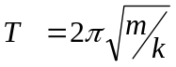 Equation 1
Squaring both sides creates the equation

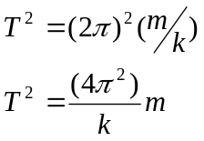 Equation 2

When the time squared and the mass attached to the spring are plotted in a linear fashion the slope of the line would equal 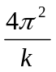.

The value of k is found by using the equation
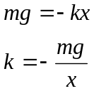 Equation 3

Therefore, when mass is 20, k=1507.69
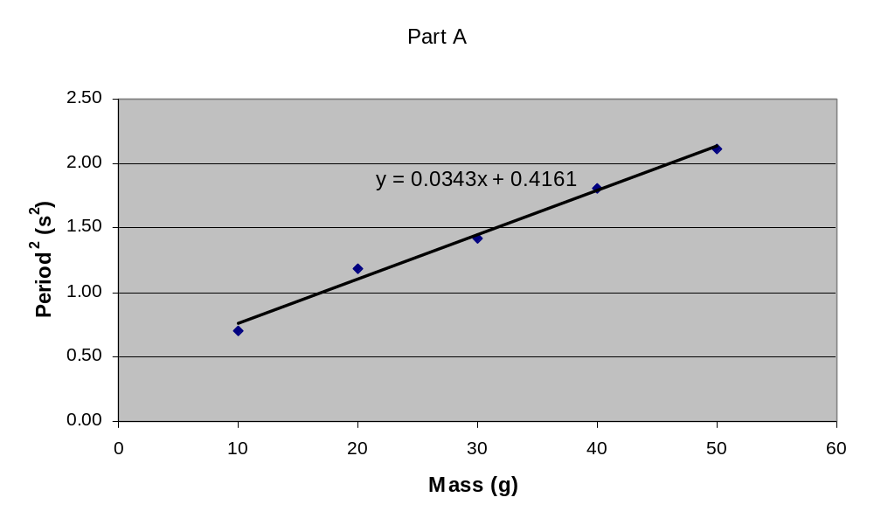Graph 1 – Plot of period squared versus the mass of the spring according to the data in Table 1.

Since the slope of the line in the graph was calculated, the k constant can now be derived.

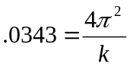
k = 1150.97
The percent error of the calculated spring constant is,
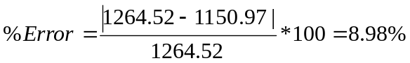
Part B

Data
In part B, the top row refers to the length of the pendulum’s string. The second row is the
time it took for the pendulum to complete ten oscillations.

length (m) .10 .20 .30 .40 .50
time (s) 6.81 9.33 11.05 11.98 13.98
Period 0.681 0.933 1.105 1.198 1.398
Period
² 0.463 0.870 1.220 1.435 1.954

Table 2 – Time of the pendulum to go through ten oscillations varying by the length of
the pendulum.

Data Analysis
In part B, the length of a pendulum, the acceleration due to gravity, and the period during
an oscillation is related through the equation,
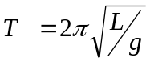 Equation 4
Where T is the period,
L is the length of the string,
g is the acceleration due to gravity.

If both sides of the equation are squared and the equation manipulated a little one gets,
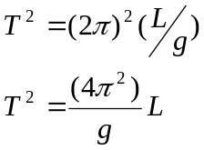 Equation 5
When the time squared and the length of the pendulum are plotted in a linear fashion
the slope of the line would equal 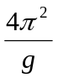.
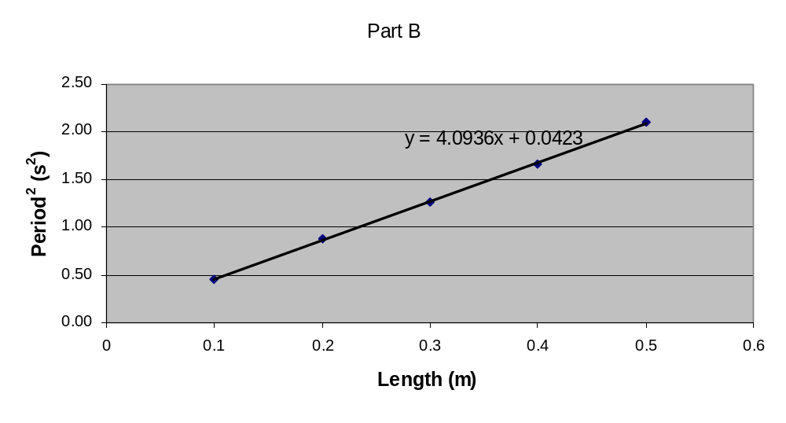 Graph 2 – Plot of period squared versus the length of the pendulum according to the data in Table 2.

Since the slope of the line in the graph was calculated, the g constant can now be derived.
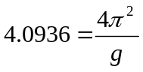
g = 9.644 m/sThe percent error of the calculated acceleration due to gravity is,
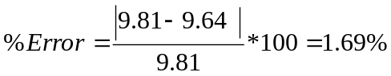In part C, we set up the oscilloscope to measure both DC and AC power sources. We started by "zeroing" the oscilloscope. Setting the coupling switch to GND allowed us to view the reference or zero-voltage point so that we could make sure it was positioned in the middle of the screen. This had to be done because we had to know where the zero point was in order to accurately measure the applied voltage sources.

We next set the DC power supply to 5 V and observed a straight line on the screen. The display was a line because the voltage level was constant with time. As we increased and decreased the voltage we saw the line move up and down the screen. Then we set the voltage back at 5 V and tried changing the VOLT/DIV knob from 5 to 1. We observed that the line jumped up four grid lines. This is because the grid lines changed from representing 5 volts to representing only 1 volt per line.

Next, we changed the oscilloscope channel so we could observe the AC voltage waveform coming from the function generator. Using the SEC/DIV knob, we adjusted the time scale so that only a few cycles of the waveform could be seen. Then we wanted to measure the frequency of the waveform. To do this we measured the time it took the wave to make one complete cycle and took the inverse of this. We found the frequency to be 1429Hz. Next, we wanted to find the voltage amplitude. To do this we changed the vertical position of the wave so that it lined up with the grid lines. Then we could easily count grid lines from peak to trough or from peak to 0 point. After adjusting this result due to the VOLTS/DIV setting, we had the amplitude.
DISCUSSION OF RESULTS:
For part A, the calculated spring constant was 1264.52.
For part B, the experimental acceleration due to gravity was 9.64 m/s²

² with a
percent error of 1.69%.
For part C, the measured amplitudes for both the DC and AC sources were very
close to the correct values. The calculated frequency for the sine wave was 1429Hz
while the function generator was set to 1500Hz. This 4.7% error was most likely
due to human error, because it was impossible to read exact measurements from the
oscilloscope.

CONCLUSION

The percent error from the calculated acceleration due to gravity shows that the experiment was accurate. A possible source of error would have been the inexactness of the human timing method. Another possible source of error would have been the friction or sliding of the pendulum string at the pivot point.

